**MCSE 1 Lecture 9**

**Network Printing**

**There are two ways of granting clients access to network printers**

1. install a printer (icon) on each computer that connects to the network printer. Don’t need a print server.

2. install a printer (icon) on a print server and connect the printer to the clients through the print server

Fig. 1 The two methods of connecting clients to a network printer

**Advantages of using a print server**

- print driver settings are controlled at the print server

- print server can send error messages to all the clients. ie. out of paper

- there is only 1 queue so users see all print jobs that are spooled

- administrator can track print usage of all users with the printer log

- print servers can download the printer drivers to the clients

**Printer Drivers**

An operating system talks to a printer the same way regardless of what printer is attached to the computer. When you connect a printer to the computer you must load a translator program called a device driver that translates what the operating system is saying into what the printer understands.

Let’s look at an analogy using languages. Let’s assume you are using an XP operating system that speaks English. You connect an HP printer that speaks French. To make the system work you must load a device driver that can translate English into French and vise-versa.

Later you add a Cannon printer which speaks German. Now you must load a device driver that speaks English and German. This is shown in figure 2.

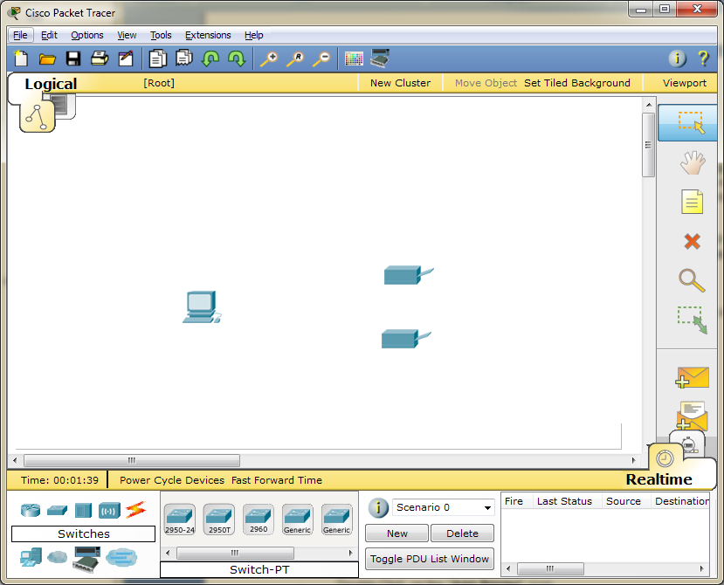

Windows 7

Cannon

HP

**English** – French

translator

**English** – German

translator

Fig. 2 Device drivers translating between Windows 7 and the printers

Now let’s assume you upgrade the operating system to Windows 10. Windows 10 speaks Spanish. To make the printers work, you must load new device drivers that speak Spanish and French for the HP printer and Spanish and German for the Cannon printer. This is shown in figure 3.



Windows 10

Cannon

HP

**Spanish** – French

translator

**Spanish** – German

translator

Fig. 3 Device drivers translating between Windows 10 and the printers

The manufacturer of the printer creates a device driver for each popular type of operating system. Quite often you get a driver DVD with the printer which usually has an automatic installation program on it.

The operating systems often contain drivers supplied by the printer manufacturers although this is getting harder to support as more printers enter the market place.

You can always go the WEB site of the manufacturer of your printer and download the printer driver that works for your printer and operating system.

**Installing a Printer (the icon/driver)**

- Open **Devices and Printers**

- Double-click on "**Add Printer**"

- Wizard steps you through the install

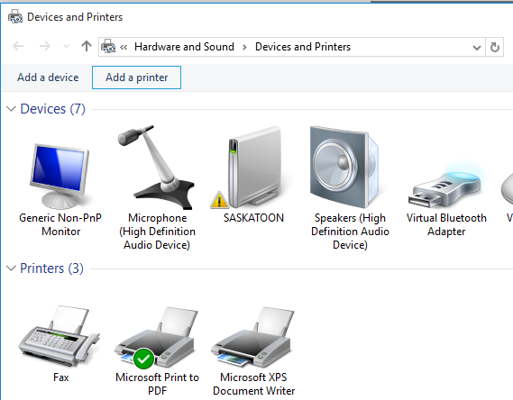

Fig. 4 Adding a new printer

**Printer Permissions**

1. **Print**

Everyone=Print (This is the default)

- send print jobs to printer

- Delete or re-sequence your own print jobs

Normally you do not bother changing the default permissions.

But... you may want to restrict access to printers such as:

a) Payroll printers that are setup for printing cheques

b) Expensive high resolution color quality print

c) high capacity printers

2. **Manage Printer**

- Pause or restart the printer

- Change spooler settings

- share printer

- Modify the printer permissions

- Change printer properties

3. **Manage Documents**

- Clean-up print queue after a printer problem has been fixed.

* pause, restart, cancel, and rearrange the order of documents submitted by anyone.

You can assign printer permissions by right-clicking on the printer and then opening the **Security** page. See figure 5.

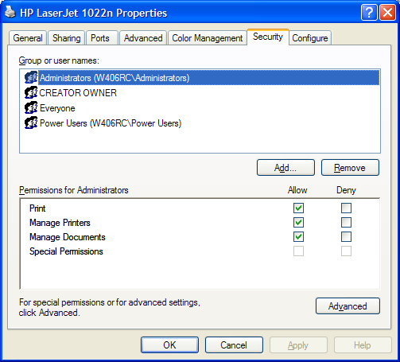

Fig. 5 The permissions that are available for a printer

**Print Spooling**

The print server stores print jobs on the hard drive and then passes them to the print device when the print device is ready. The storing of print jobs on the hard drive is called "spooling". By default the location of the spool folder is:

**%systemroot%\system32\spool\PRINTERS**

%**systemroot**% is the Windows directory on whatever drive it happens to be on.

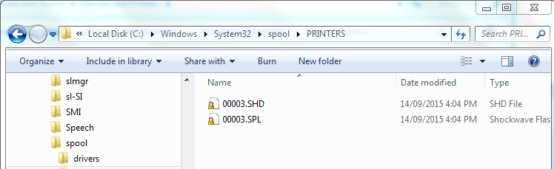

Fig. 6 The default location of the print spooler on the hard drive

**Why change the location of the Print Spooler**

Relocate the spooler folder to another hard drive if possible. The advantages are

1. Improved Performance - If the spooler is on a drive with its own

controller, printing will not hamper the operation of the operating

system; no contention for hard drive heads.

2. Won't take up valuable disk space - the operating system and

swap file will not be starving for disk space as the spooler folder fills

up with lots of large print jobs.

3. Security - Do not give users access to the drive where the

operating system is. You can grant access to the drive where the

spooler is.

4. Set Disk Quotas - so users can't use more than their fair share of

the spooler space.

**Changing Spooler Location**

With Windows 7 and higher operating systems, you must load the print manager snap-in by opening an MMC console. In a RUN box type **mmc**. (MMC stands for Microsoft Management Console). Select **Add/Remove Snap-in…**

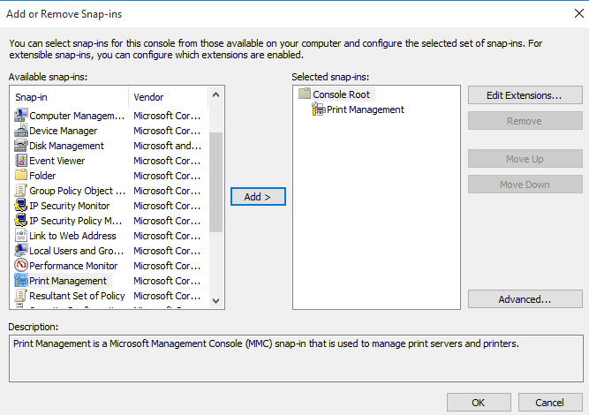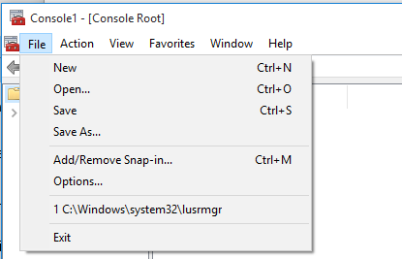

Fig. 7 Adding the Print Management snap-in

Expand the folders in the Print Management snap-in. Right-click on the server and select properties. You can change the location of the print spooler on the **Advanced** page.

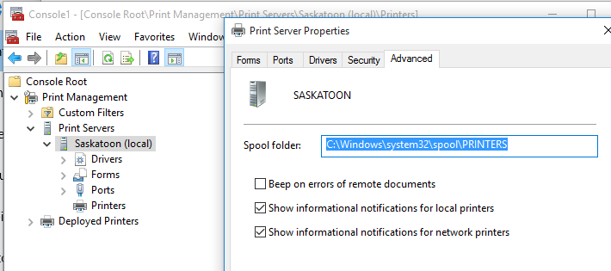

Fig. 8 Relocating the print spooler on Windows 10

**Printer Pooling**

In order to facilitate high printing requirements multiple printers can be "pooled" to one printer icon.

When a print job for the pooled printers is sent, it queries all the printers in the pool. The first printer to respond gets the print job. This process is repeated until the queue is empty. See figure 9

Printers must be close together when pooled because the user has no way of predicting which printer the job will come out on.

Printers must use the same print driver; ie. be the same model. Only one print driver was loaded for the printer pool so it must work with all printers.

A single high speed printer is not as good as a multiple cheap pooled printers because printing ceases when the high speed printer fails.

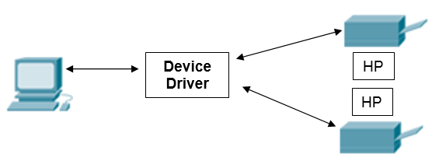

Fig. 9 Printer Pooling

Right click on printer icon -> **Properties** -> **Ports** Tab -> Enable printer pooling.

See figure 10. Check the boxes to indicate which printers you want pooled.

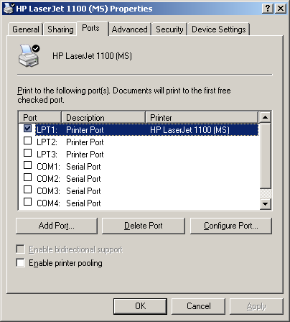

Fig. 10 Printer pooling

**Redirecting a Print Queue**

If there are print jobs waiting to be printed in the queue of a printer that suddenly fails, you can redirect those pending print jobs to another printer.

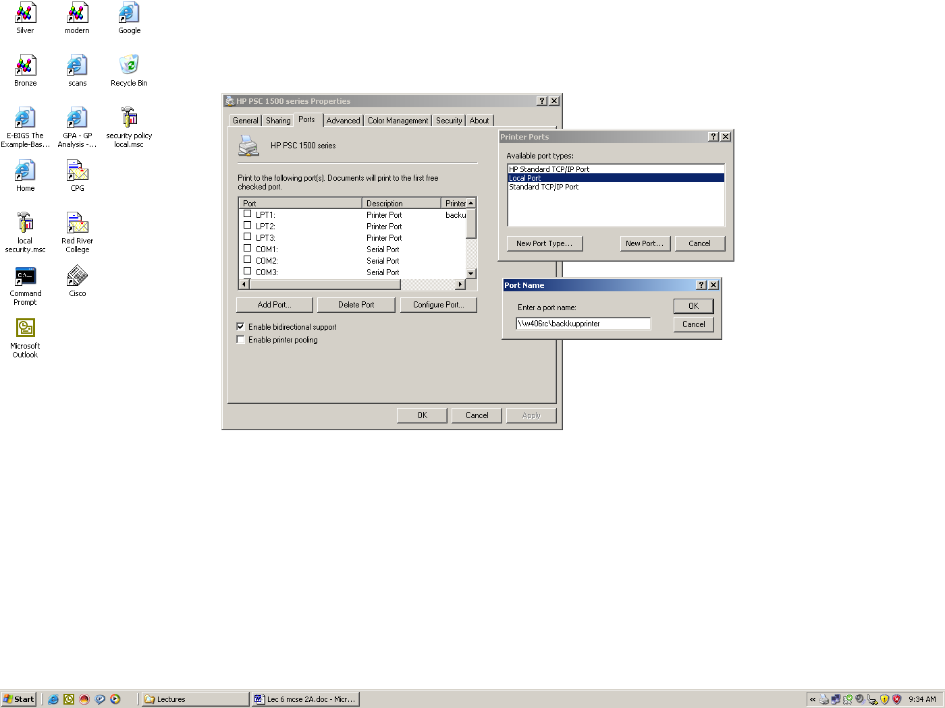

Fig. 11 Redirecting the print queue to a different printer

Fig. 12 shows how the transferred jobs show up as “Local Downlevel Document” on the backup printer.

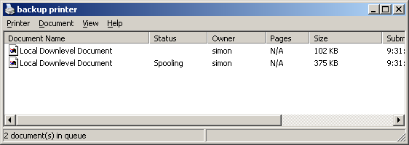

Fig. 12 The backup printer showing the transferred files

One major concern about transferring print jobs between printers is that, the printers must use the same print drivers because the print jobs on the failed printer are already configured using its print driver.

**Printer Connections**

There are two currently popular methods of connecting printers to computers.

**1. Locally through a USB** **port**

Just about all printers can be connected directly to a computer through the USB port. You can then share this printer with other computers. This computer becomes a print server. This is a common printer arrangement for a peer-to-peer network.

**2. Networked Printer**

It is becoming more common to find printers that contain a NIC. These printers can be connected to the Ethernet network. They have their own IP address. All the computers can print directly to the network printer or for better printer control, one computer can be configured to print to the network printer. All the other computers will then send their print jobs to this print server. This scenario is frequently used in a client-server network.

**Who has access to installed printers**

If the printer is installed directly to a computer through the USB or parallel port or the computer is pointing directly to a networked printer with its own IP address, all users who log in locally will have access to it.

If the printer is found on a print server, then only the user that installed the printer on the computer has access to it. ie.) If user A installs a printer that is pointing to a shared printer on a print server user B will not see it when he logs in.